Creating of Resources using terraform
EC2 Instance.

Terraform main commands;
Main commands:
- init Prepare your working directory for other commands
- validate Check whether the configuration is valid
- plan Show changes required by the current configuration
- apply Create or update infrastructure
- destroy Destroy previously-created infrastructure

Using the editor of your choice, create the provider.tf file as below;

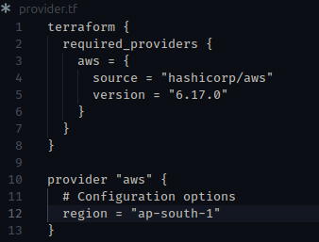

Create the Ec2.tf file as below;
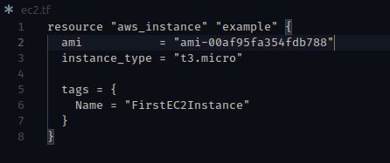

Commands to create the EC2 instance using terraform.
1. In your terminal run terraform init command. This will install the necessary terraform files.

Two additional files will be created terraform.lock.hcl and terraform-provider-aws…, do not make changes to them as they required for terraform to run better. Always make changes to terraform.tf files.

2. Terraform validates – validates if the configuration is okay. Incase of any error in the code, it will able to point it out.

3. terraform plan – Shows the resources that will be created.

You will get this notification; Note: You didn't use the -out option to save this plan, so Terraform can't guarantee to take exactly these actions if you run "terraform apply" now.
This means that your terraform plan was not saved. Do so by using the following command terraform plan -out plan.txt. Your plan will be saved in a file named plan.txt.

4. terraform apply. This creates the AWS resources planned earlier (ec2) to the AWS management console.
Note: you can add -auto-approve to the command to eliminate a prompt whereby you will be required to say yes or no for the resources to be created.
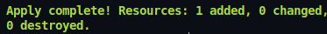

A file named terraform.tfstafe will be created which keeps track of all the changes that you are making, do not delete it.

5. terraform destroy -auto-approve. Destroys the created resource (Ec2 instance).

